Dear, Charlie:

From the Raspberrypi Soc (BCM2837) specification, both falling and rising edge events can be enabled for a GPIO pin, but there is no way to distinguish between the 2 events from the GPIO event detect status register when the transition is triggered. There is only 1 bit set in the GPIO event detect status register (GPEDSn) when the interrupt happens.

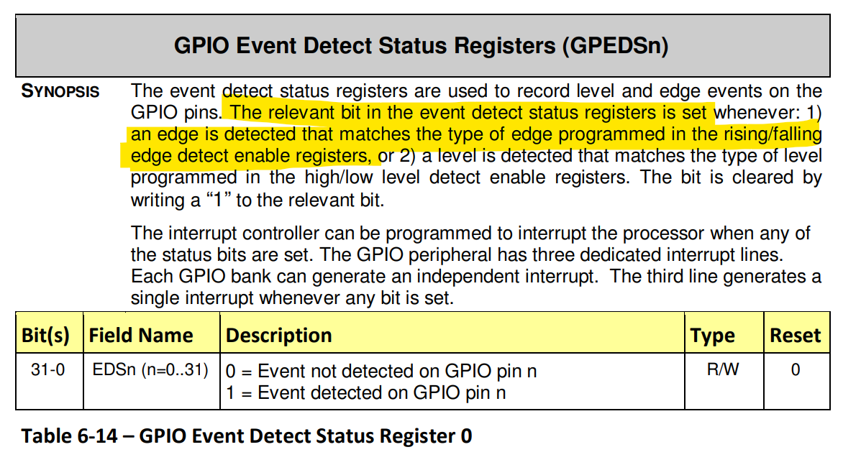

Thanks very much!

Br,

Junhua

2024.08.07